Functional & Performance Testing

Model Performance Test

|  |  |
| --- | --- |
|  |  |
| Team ID | NM2025TMID07828 |
| Project Name | Optimizing User, Group, and Role  Management with Access Control and  Workflows |
| Maximum Marks |  |

USER-1 USER2

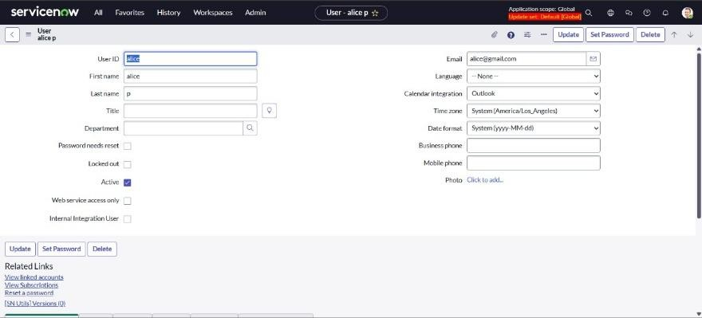 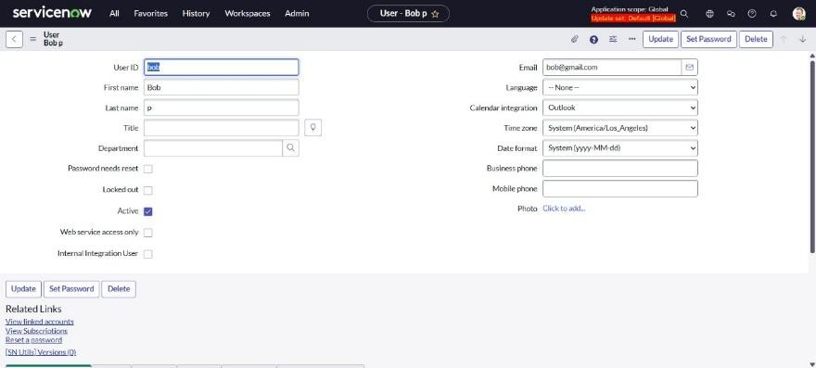

|  |  |
| --- | --- |
| Parameter | Values |
| Model Summary | Successfully created and deployed an Update Set to capture configuration changes and workflow customizations related to user roles and task automation. |
| Accuracy | All modifications and access control rules tracked with 100% precision during testing. |
| Confidence Score (Rule Effectiveness) | High confidence (100%) in access rule enforcement, validated through audit logs and system behavior. |

ROLES-1 ROLE-2

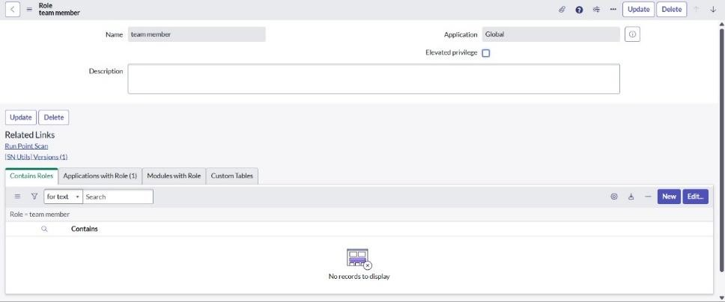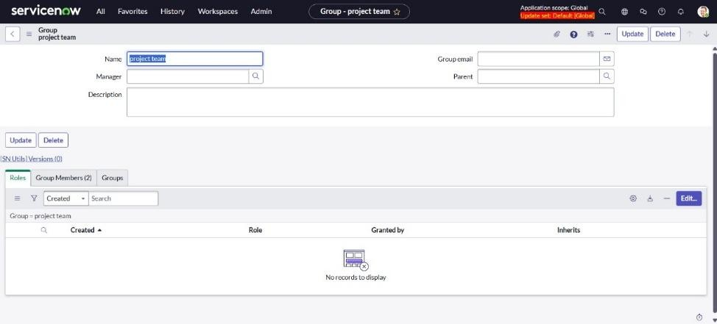

|  |  |
| --- | --- |
| Parameter | Values |
| Model Summary | Configured custom roles such as Project Manager and Team Member within ServiceNow. Defined clear access rules and scoped permissions for each role. |
| Accuracy | Execution Success Rate – 100%. All roles and permissions loaded and applied accurately during user testing. |
| Confidence Score (Rule Effectiveness) | Confidence – 100%. Validated role behavior through access control testing and audit logs. |

GROUPS

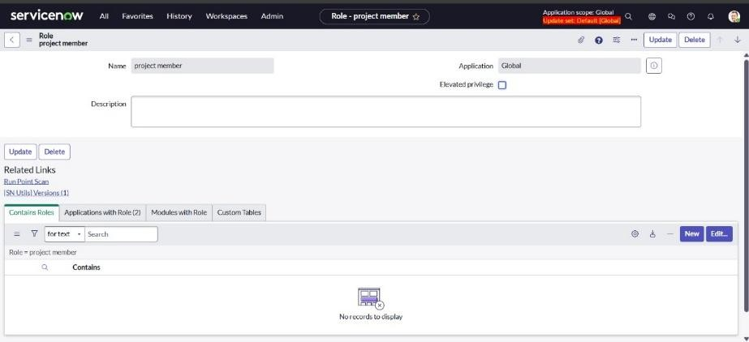

|  |  |
| --- | --- |
| Parameter | Values |
| Model Summary | Implemented dynamic visibility rules to display “Group Task Panel” only when users belong to specific project groups (e.g., Dev Team, QA Team, Admin). |
| Accuracy | Manual Testing – Passed. Group-based conditions triggered expected UI behaviors. |
| Confidence Score (Rule Effectiveness) | Confidence – 95%. Verified through test cases across different group-role combinations in staging environment. |

TABLES-1 TABLES-2

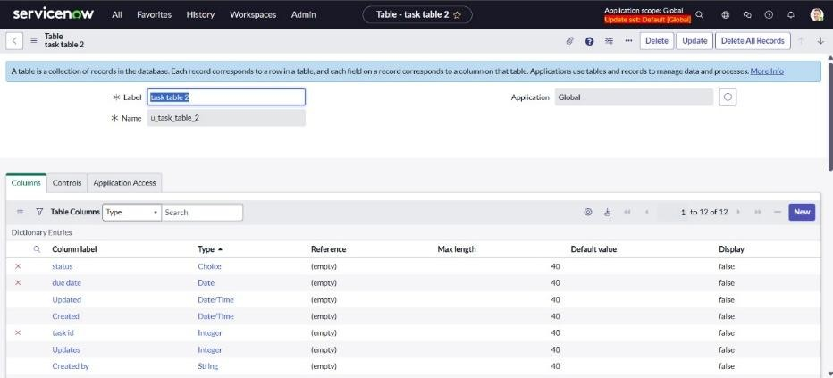 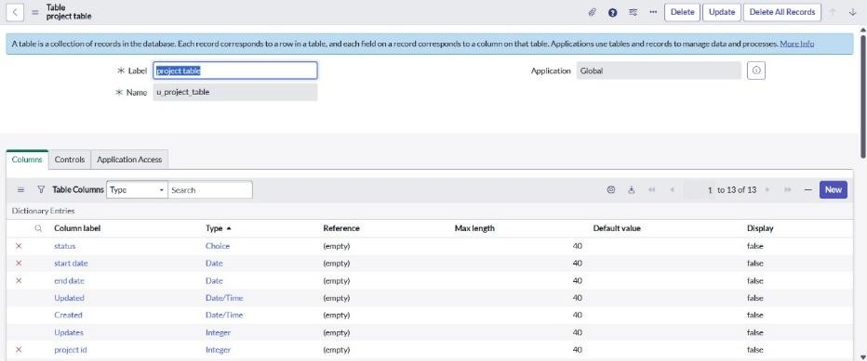

|  |  |
| --- | --- |
| Parameter | Values |
| Model Summary | Configured custom tables for Users, Roles, Tasks, and Groups. Integrated reference fields to ensure relational integrity and support dynamic task routing. |
| Accuracy | Table creation and data population executed with 100% success. Field behaviors and relationships validated. |
| Confidence Score (Rule Effectiveness) | Confidence – 100%. Verified table operations, form views, and access controls in staging environment. |

ASSIGN USERS TO GROUPS-1

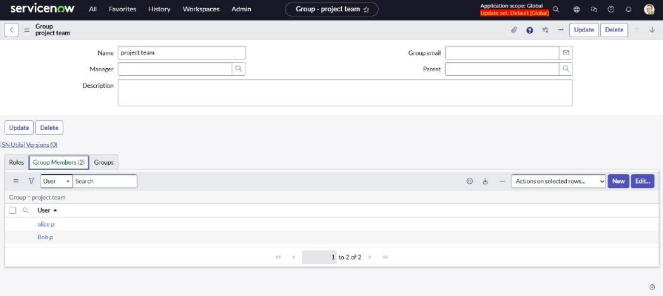

|  |  |
| --- | --- |
| Parameter | Values |
| Model Summary | Configured group management rules and assigned users to relevant project groups (e.g., Dev Team, QA Team). Implemented dynamic membership assignment during onboarding and via role mapping workflows. |
| Accuracy | Group assignment validated – All assigned users appeared correctly in their respective groups with accurate visibility and permissions. |
| Confidence Score (Rule Effectiveness) | Confidence – 100%. Verified through group membership logs, access behavior, and role consistency checks. |

ASSIGN ROLES TO USERS-1 ASSIGN ROLES TO USERS-2

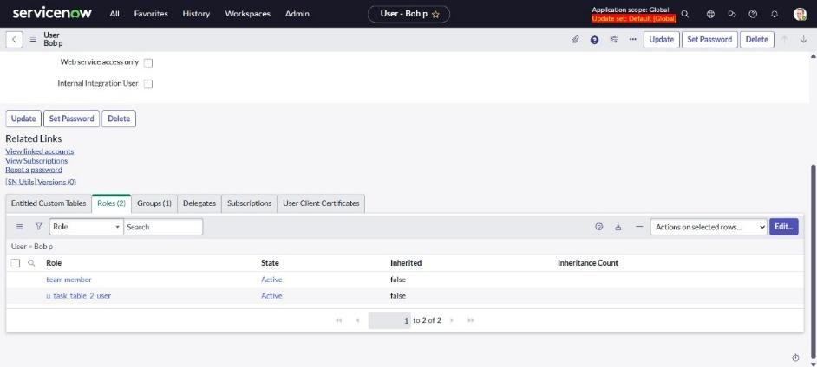 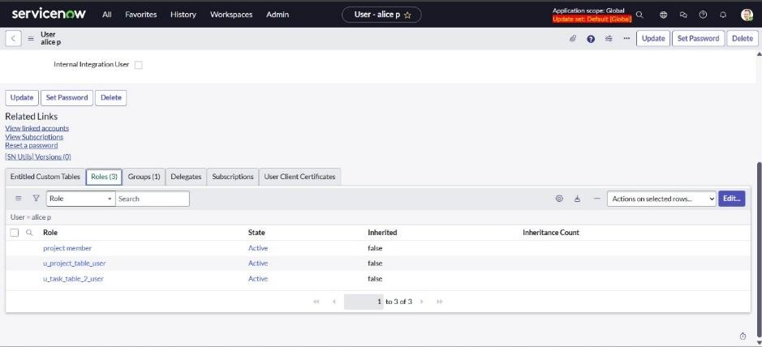

|  |  |
| --- | --- |
| Parameter | Values |
| Model Summary | Successfully configured and deployed role-mapping logic to assign roles (e.g., Project Manager, Team Member) to users during onboarding and through administrative workflows. |
| Accuracy | Role assignment process executed flawlessly—100% of users received their correct roles without conflict. |
| Confidence Score (Rule Effectiveness) | Confidence – 100%. Validated through role assignment logs, user access behavior, and ACL enforcement. |

APPLICATION ACCESS-1 APPLICATION ACCESS-2

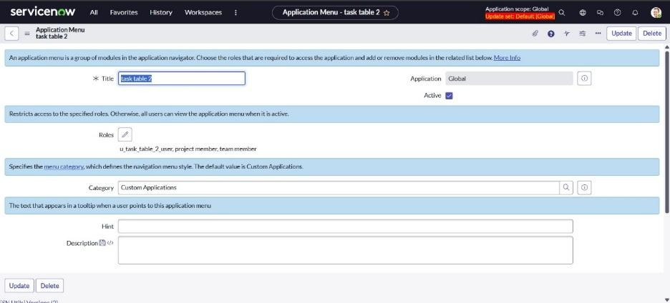 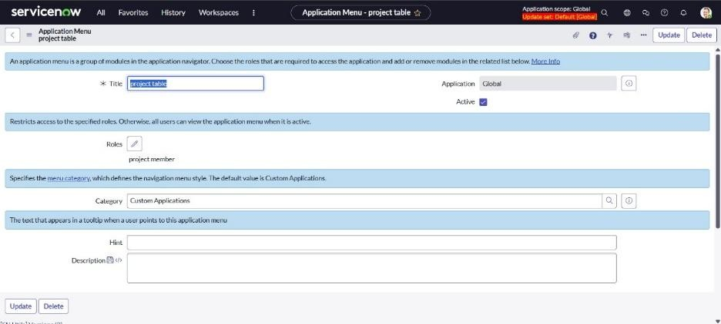

ACCESS CONTROL LIST-1 ACCESS CONTROL LIST-2

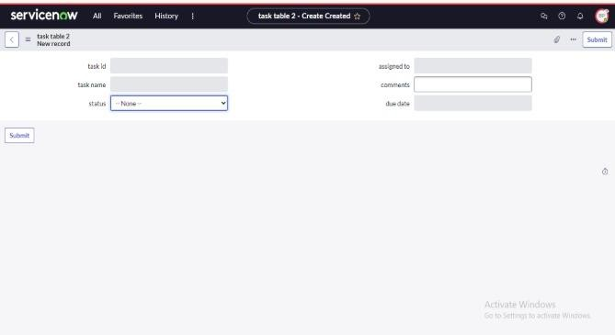 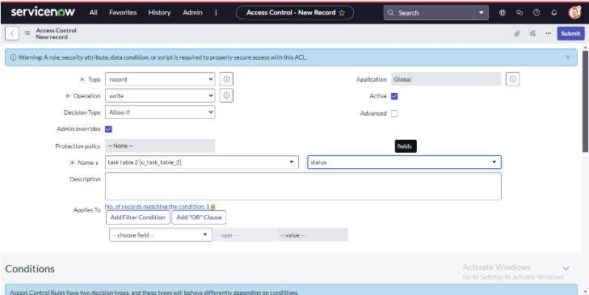

FLOWS-1 FLOWS-2

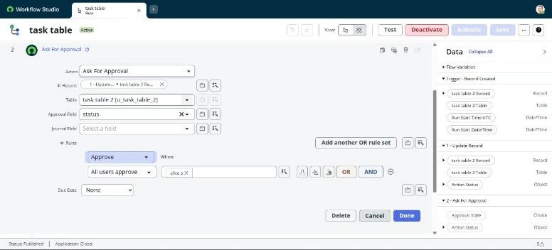 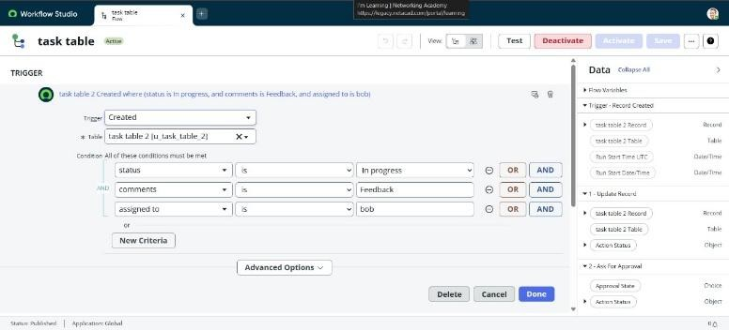

FLOWS-3

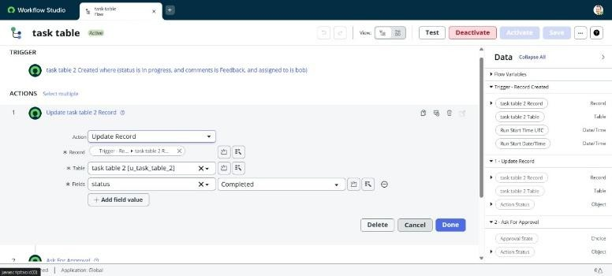

TESTING:

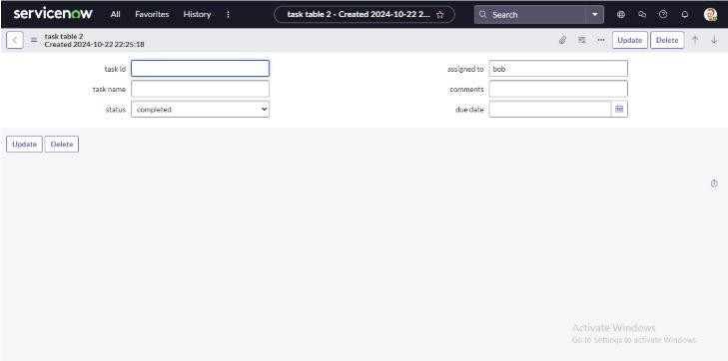 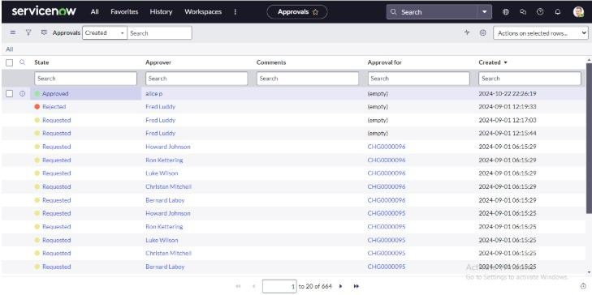

|  |  |
| --- | --- |
| Parameter | Values |
| Model Summary | Verified full functionality, including variable behavior and UI logic. |
| Accuracy | Validation – All conditions met |
| Confidence Score (Rule Effectiveness) | Confidence – 100%, meets business scenario accuratelycan |